Day-36(17/9/2025)
Emp ID : 110714877
NAME :Kinnera venkatamma

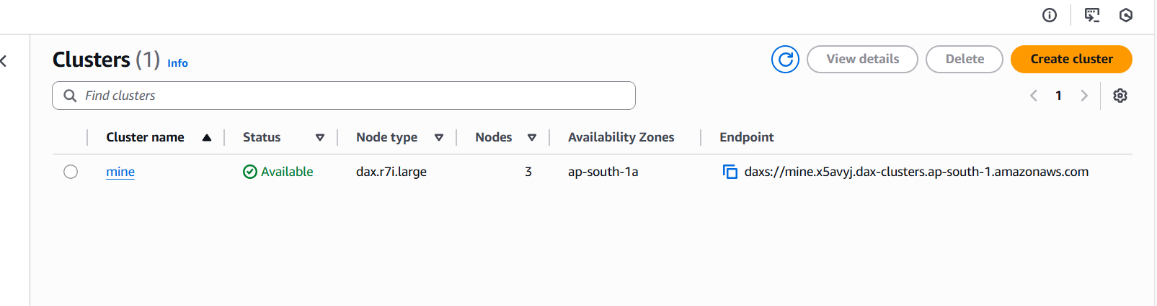

Task 03: What is JUNIT?

JUnit is an open-source framework for Java developers to write and run automated unit tests for their code. It helps developers verify that individual code units, such as methods, function correctly by allowing them to create repeatable test cases that provide quick, automated feedback on code quality. By catching bugs early and ensuring code reliability, JUnit supports test-driven development (TDD) and helps produce more stable and maintainable Java applications.

Task 04: What is the latest version of Junit

JUnit » 4.13.2

Task 05: Write a test case to check if 2 strings or equal?

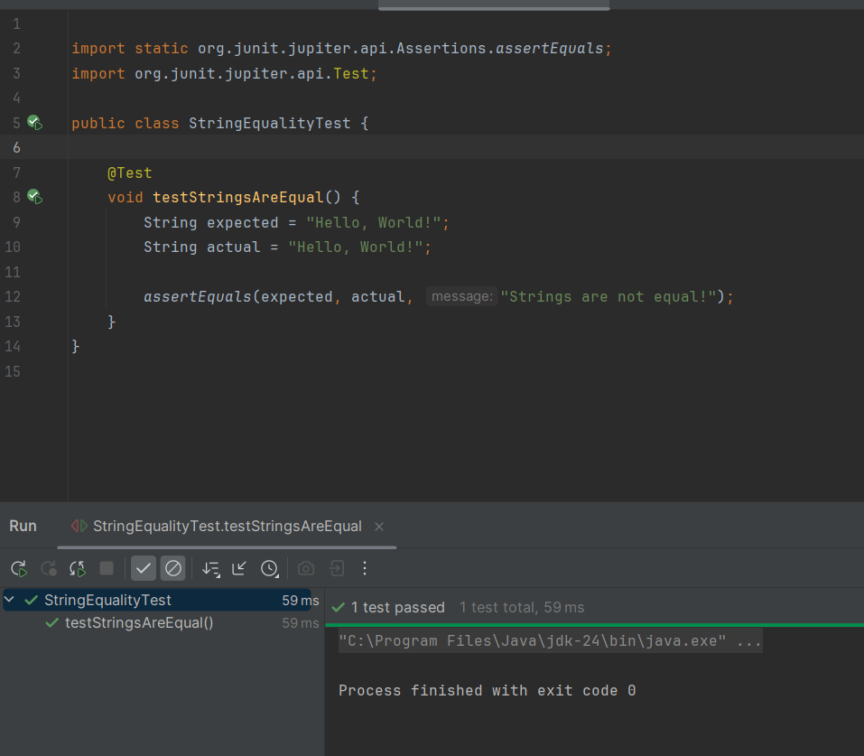

Task 06: Write the list of tags in Junit5.

JUnit 5 uses the @Tag annotation to apply tags to test classes or individual test methods. There isn't a predefined, exhaustive "list of tags" in JUnit 5, as tags are user-defined strings that categorize and filter tests.

Task 08: What are Assertions?

Assertions in JUnit are methods used within unit tests to verify that the actual outcome of a code under test matches the expected outcome. They are fundamental to the "self-validating" nature of unit tests, as they explicitly state the conditions that must be true for the test to pass.
When an assertion fails, JUnit reports a test failure, providing details about the discrepancy between the expected and actual results. This mechanism is crucial for identifying bugs and ensuring the correctness of the software.
The Assertions class in JUnit 5 (or Assert in JUnit 4) provides a comprehensive set of static methods to perform various types of checks.

Task 09: What are Assumptions?

In JUnit, Assumptions are conditions that a test requires to be true for it to proceed. If an assumption is not met, the test is aborted or skipped, rather than failing, making them useful for running tests conditionally in specific environments or when external resources are unavailable. Key methods like assumeTrue(), assumeFalse(), and assumingThat() in the org.junit.jupiter.api.Assumptions class (in JUnit 5) allow you to define these conditions.

Task 10: What is Disabling Test cases? When will we use them?

Disabling test cases in JUnit involves preventing specific test methods or entire test classes from executing during a test run. In JUnit 5, this is achieved using the @Disabled annotation.

When to use @Disabled:
Known issues or bugs: When a test is failing due to a known bug that is actively being worked on, but you still want to run other tests.
Incomplete features: When a feature is still under development, and its associated tests are not yet stable or complete.
Temporary skipping during refactoring: During extensive code refactoring, you might temporarily disable certain tests that are affected by the changes to focus on the core refactoring.
Reliance on unavailable external dependencies: If a test requires an external dependency (e.g., a database, an external service) that is currently unavailable, you can disable the test until the dependency is accessible.
Performance-intensive tests: In some cases, very long-running or resource-intensive tests might be disabled for faster local development cycles, and only run in a dedicated CI/CD environment.

Task 11: Give the names of Conditional Test Executions.

JUnit 5 provides several annotations for conditional test execution, allowing tests to be enabled or disabled based on various conditions. These annotations are found in the org.junit.jupiter.api.condition package.
The names of the annotations for conditional test execution in JUnit 5 are:
Operating System Conditions:
@EnabledOnOs
@DisabledOnOs
JRE Conditions:
@EnabledOnJre
@DisabledOnJre
@EnabledForJreRange
@DisabledForJreRange
System Property Conditions:
@EnabledIfSystemProperty
@DisabledIfSystemProperty
Environment Variable Conditions:
@EnabledIfEnvironmentVariable
@DisabledIfEnvironmentVariable
Custom Conditions:
@EnabledIf
@DisabledIf

Task 12: What is Automated Testing?

Automated testing is a software testing method that uses scripts and tools to execute tests automatically, compare actual results with expected outcomes, and verify the software's functionality, performance, and reliability without human intervention. This technique is crucial for CI/CD pipelines, enabling faster, more frequent releases by providing quick feedback on code changes, increasing test coverage, and ensuring consistency and accuracy in testing.

Task 13: List down some automated testing tools and frameworks

Automated Testing Tools:

Selenium:
A widely used open-source framework for automating web application testing across various browsers and platforms.

Appium:
An open-source tool for automating native, hybrid, and mobile web applications on iOS, Android, and Windows platforms.

Cypress:
A modern, JavaScript-based end-to-end testing framework for web applications, offering fast execution and real-time reloads.

Playwright:
A powerful open-source framework from Microsoft for reliable end-to-end testing of web applications across browsers.
Katalon Studio:
A comprehensive automation solution for web, API, mobile, and desktop testing, offering both scripting and low-code options.

TestComplete:
A commercial tool for automating tests across desktop, web, and mobile applications, supporting multiple scripting languages.

Ranorex:
A commercial tool for desktop, web, and mobile test automation, featuring robust object recognition and codeless test creation.
Postman:
Primarily an API testing tool, it allows for automated testing of REST, SOAP, and GraphQL APIs.
JMeter:
An open-source Java-based tool for load testing and performance measurement of various services and protocols.
ACCELQ:
An AI-powered, codeless test automation platform for multi-channel testing (API, backend, desktop, mobile, web).
Automated Testing Frameworks:
Behavior-Driven Development (BDD) Frameworks (e.g., Cucumber, SpecFlow): Focus on defining software behavior in natural language (like Gherkin) to facilitate collaboration between technical and non-technical stakeholders.
Data-Driven Frameworks: Separate test data from test scripts, allowing the execution of the same test with various data sets for comprehensive coverage.
Keyword-Driven Frameworks: Utilize a set of keywords to represent actions and objects, enabling testers with less programming knowledge to create test scripts.
Modular Frameworks: Organize test scripts into smaller, reusable modules, enhancing maintainability and reusability.
Hybrid Frameworks: Combine elements from multiple framework types (e.g., data-driven and keyword-driven) to leverage their respective strengths.
Unit Testing Frameworks (e.g., JUnit, TestNG, NUnit, Pytest): Designed for testing individual units or components of code in isolation during the development phase.

Task 14: What is the life cycle of Test automation

The automation testing life cycle (ATLC) is a multi-stage process that includes six key phases: determining the scope of automation, selecting the appropriate automation tool, planning and designing tests, setting up the test environment, developing and executing test scripts, and analyzing results and reporting. These phases provide a structured approach to introducing and managing automated tests, ensuring a more efficient and effective testing process for software.

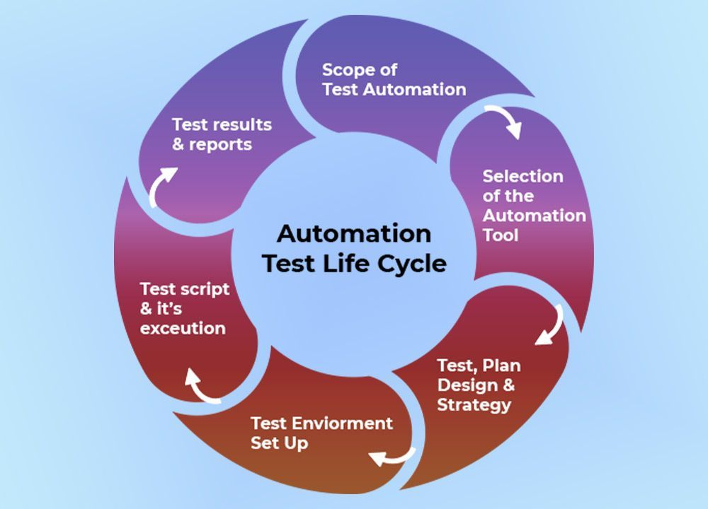

Task 15: Write a JUNIT5 code to use @Suite tag

To utilize the @Suite annotation in JUnit 5 for creating a test suite, you need to include the junit-platform-suite-engine dependency in your project.
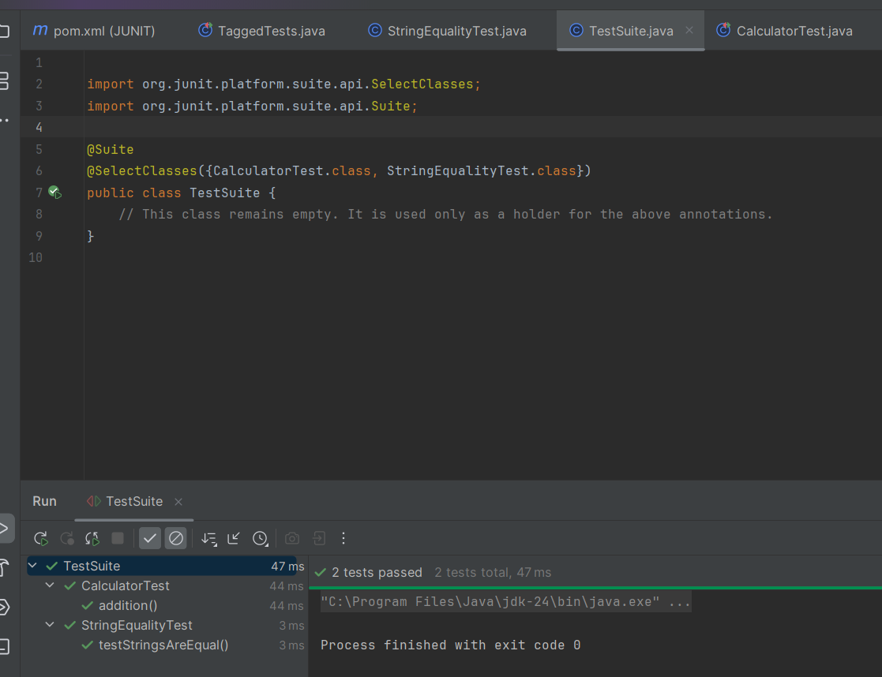

Task 16: Write JUNIT5 code to use @fast and @slow tags.

To tag tests as @fast or @slow in JUnit 5, you use the @Tag annotation on either the test class or individual test methods. You can then configure your build tool (like Maven or Gradle) to include or exclude tests based on these tags.

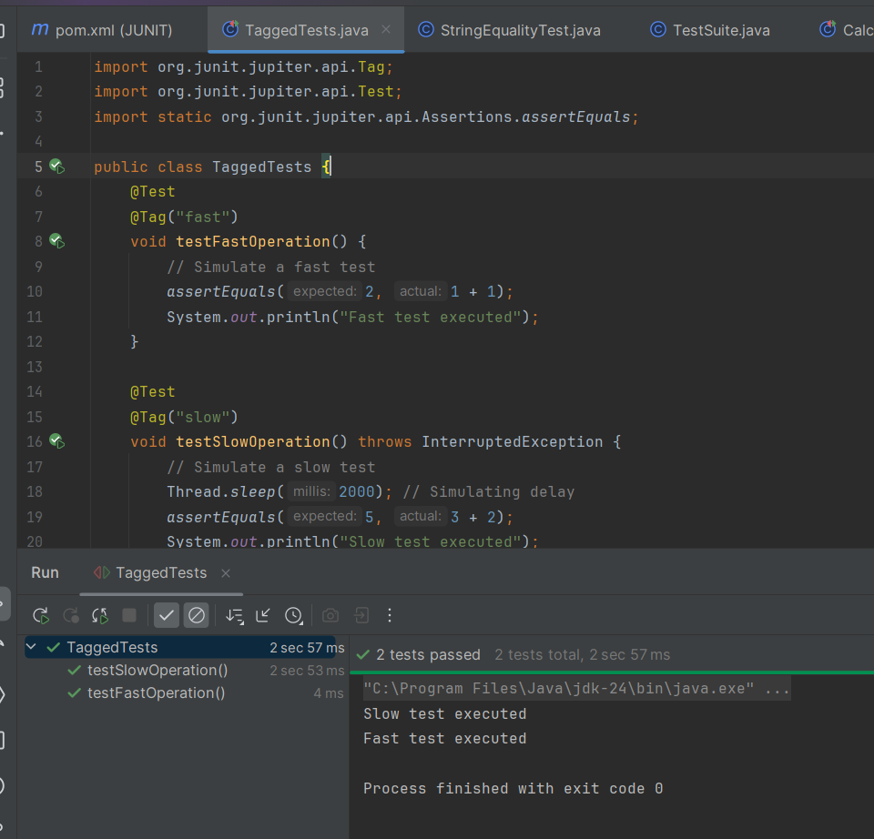


Task 17: How many types of primary keys does DynamoDB use?

5
4
3
2

Task 18:____ indexes enable you to query table data using a different key?

Composite
Secondary
Primary

Task 19: DynamoDB uses how many types of secondary indexes?

5
4
2
3

Task 20: Eventually Consistent readings always return current data?

True
False

Task 21: Which of the following data-reading action in DynamoDB receives a primary key and returns the corresponding item's attributes?

GetItem
BatchGetItem
Scan
Query

Task 22: DynamoDB often ensures consistency across all copies in less than a second.

True
False

Task 23: All local secondary indexes retain partition and sort keys from parent tables by default?

True
False

